

CS 465 Project Software Design Document
Version 2.0

Table of Contents

CS 465 Project Software Design Document 1
Table of Contents 2
Document Revision History 2
Instructions 2
Executive Summary 3
Design Constraints 3
System Architecture View 3
Component Diagram 3
Sequence Diagram 4
Class Diagram 4
API Endpoints 4
The User Interface 4

Document Revision History

Version | Date | Author | Comments
2.0 | 10-19-2025 | Kain Mason

Instructions

Fill in all bracketed information on page one (the cover page), in the Document Revision History table, and below each header. Under each header, remove the bracketed prompt and write your own paragraph response covering the indicated information.

Executive Summary

The Travlr Getaways application was developed using the MEAN stack (MongoDB, Express, Angular, Node.js). The architecture separates the customer-facing website from the administrator single-page application (SPA). Customers can browse trips and view details rendered through Express and Handlebars, while administrators log in to the Angular SPA to create, edit, and delete trips via secure REST API calls to MongoDB. JWT-based authentication and modular controllers help keep the system secure, scalable, and easy to maintain. This design meets Green Pace’s goal of a maintainable, data-driven travel booking solution.

Design Constraints

Development was limited to open-source tools .The project runs locally without Docker or cloud deployment. The system uses HTTP rather than HTTPS and stores environment variables in a local .env file. Because the database is local, all data is seeded through a script and not hosted externally. These constraints limit scalability but simplify configuration for educational purposes and ensure consistency during grading.

System Architecture View

The Travlr Getaways setup follows a simple three-tier layout that keeps things organized — presentation, logic, and data.

Presentation layer: This covers the front-end stuff — the customer site built with Express and Handlebars, and the admin side built with Angular.

Logic layer: This is where the Express controllers handle routing, data checks, and authentication using JWT.

Data layer: All the actual trip and user info lives in MongoDB, managed through Mongoose models.

Both the customer site and the admin app connect through the same REST API, which keeps the data consistent and makes the whole project easier to maintain and update later on.

Component Diagram

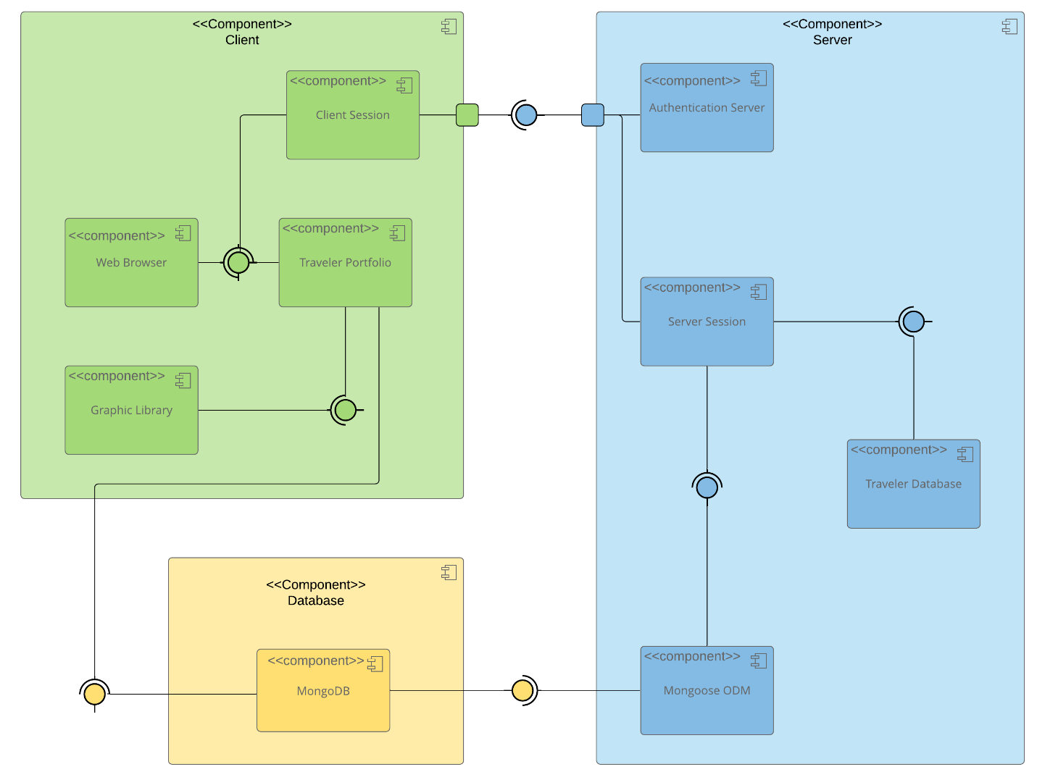

A text version of the component diagram is available: CS 465 Full Stack Component Diagram Text Version.

[Customer Browser] → [Express Server] → [Handlebars Templates]
[Admin Angular SPA] → [REST API Endpoints] → [Controllers] → [Mongoose Models] → [MongoDB Database]
The customer browser renders HTML views through Express and Handlebars, while the admin SPA sends API requests to the same Express server. Controllers call Mongoose models to read and write trip data in MongoDB.

Sequence Diagram

Customer → Express: GET /travel
Express → Controller: fetchTrips()
Controller → MongoDB: find({})
MongoDB → Controller: Trip[]
Controller → Express: render(travel.hbs, Trips)

Admin SPA → Express: PUT /api/trips/:id
Express → Auth Middleware: verifyToken()
Auth Middleware → Controller: updateTrip()
Controller → MongoDB: updateOne()
MongoDB → Controller: ack
Controller → Admin SPA: 200 OK
This flow shows how the customer side retrieves trips for display and how the admin side updates data using secure API calls. Each tier communicates through structured requests and JSON responses.

Class Diagram

Class Trip {
code: String
name: String
length: String
start: Date
resort: String
perPerson: Number
image: String
description: String
}

Class User {
email: String
passwordHash: String
role: String
}

User 1 → * Trip (createdBy)
The Trip class stores travel information for each destination, while the User class handles authentication and authorization. A user can create multiple trips, but each trip references its creator ID.

API Endpoints

Method | Purpose | URL | Notes
GET | Retrieve all trips | /api/trips | Returns JSON array of trips
GET | Retrieve trip by code | /api/trips/:code | Returns single trip object
POST | Create new trip | /api/trips | Requires JWT authentication
PUT | Update trip | /api/trips/:id | Requires JWT authentication
DELETE | Remove trip | /api/trips/:id | Optional admin function

The User Interface

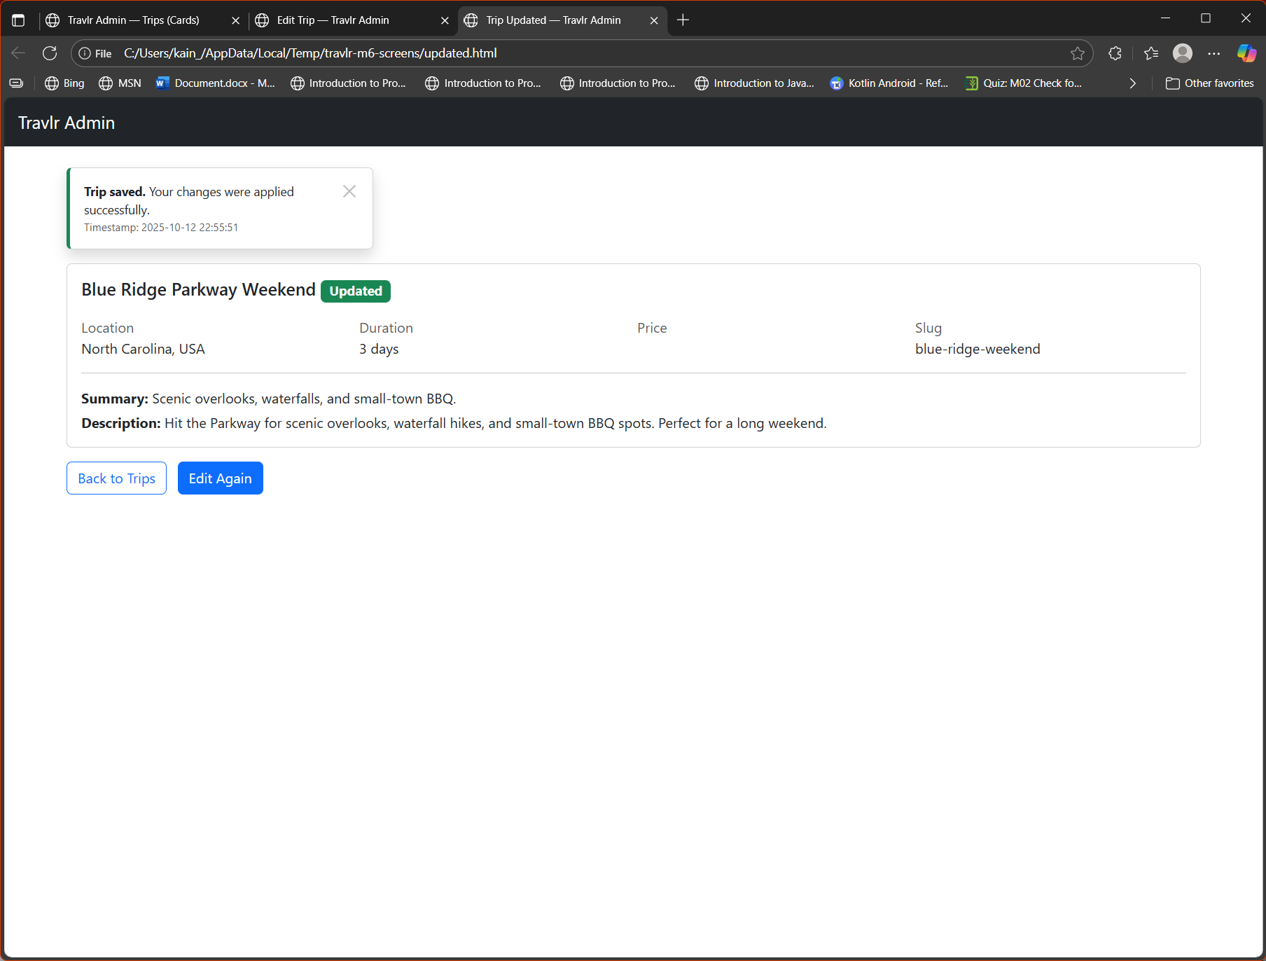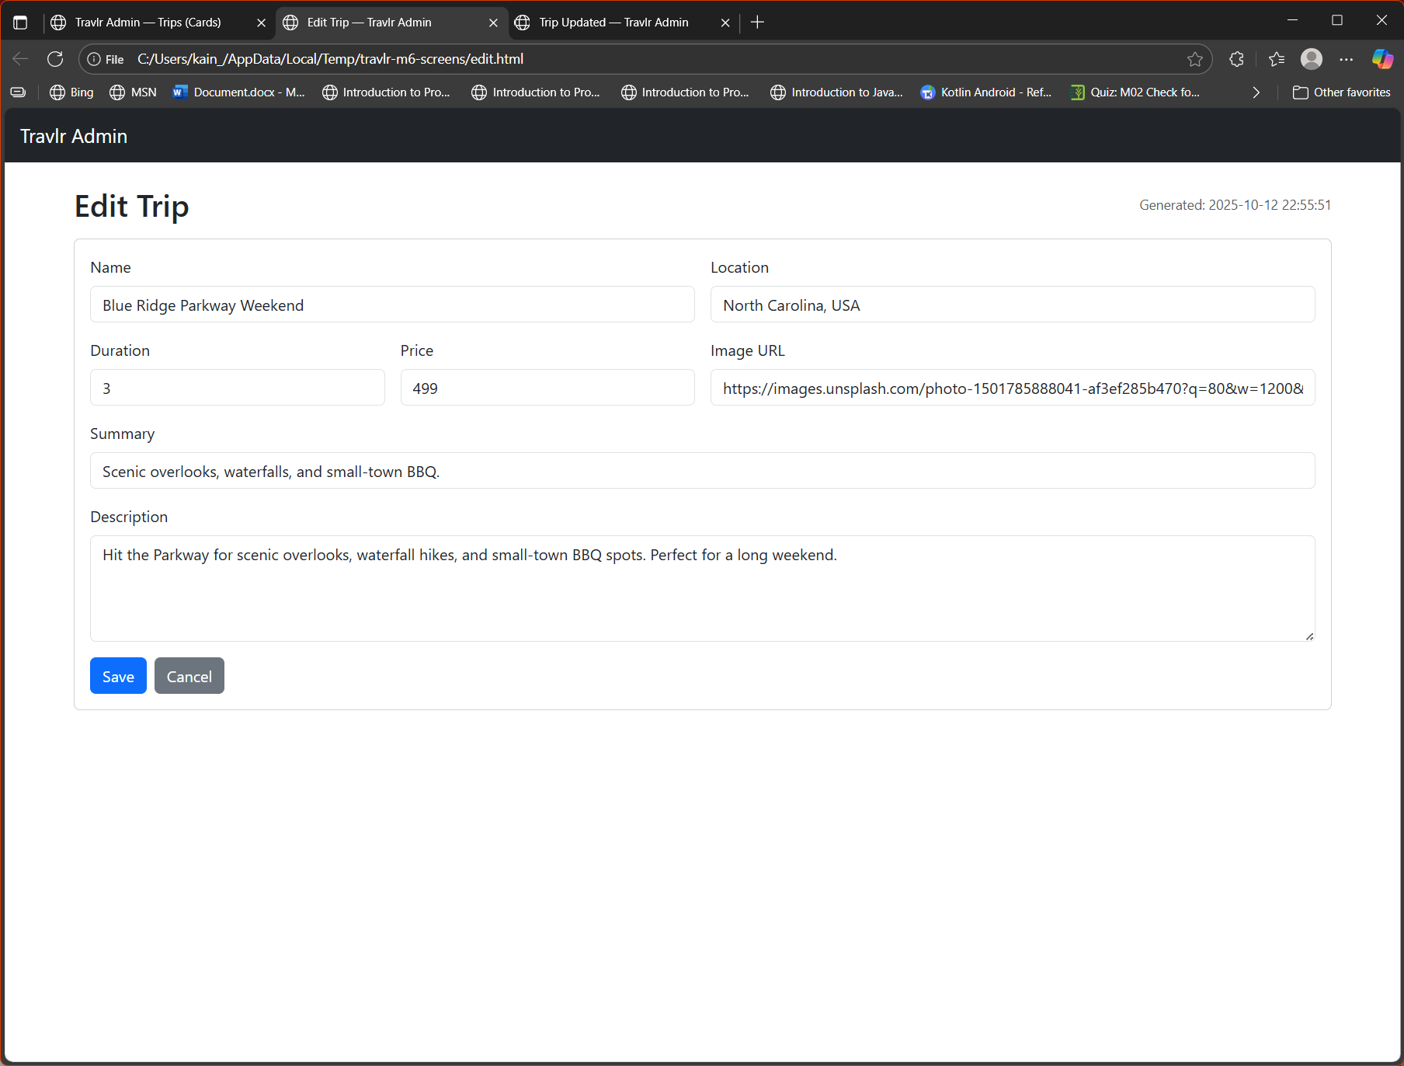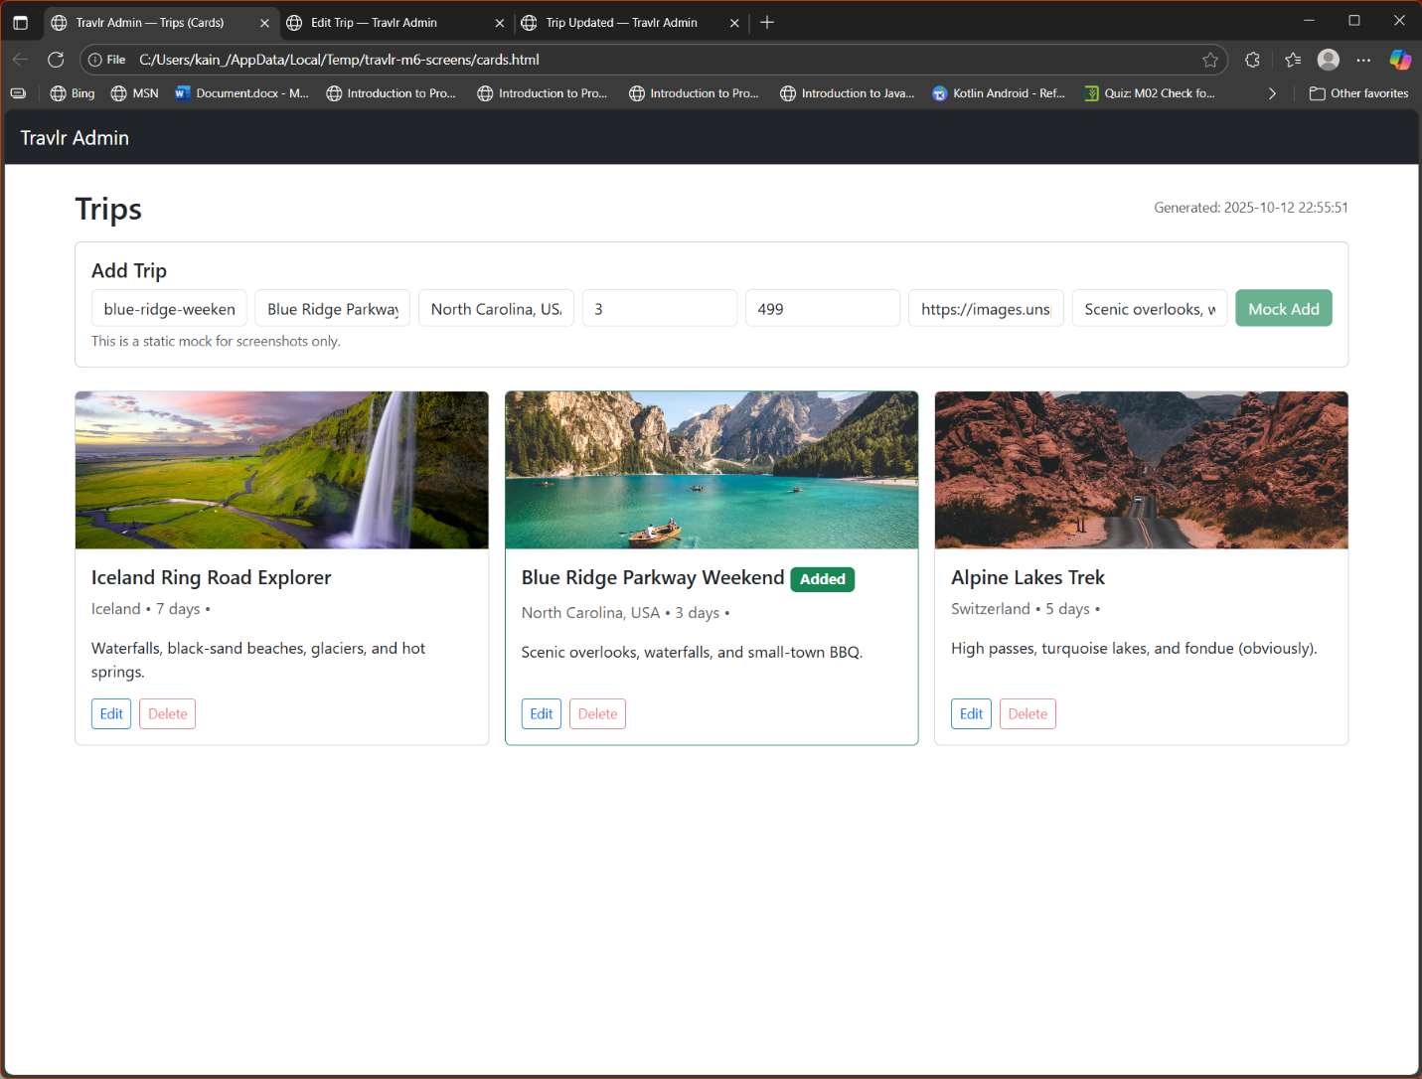
The Angular SPA uses modules, components, services, and guards for authentication. It differs from the Express structure by binding data directly to templates through TypeScript and two-way binding. Testing confirmed that GET and PUT operations successfully retrieve and update MongoDB data in real time through the API.

